Resizing images for Waverley Camera club

Size of the image needs to be 1920x1080, colour space sRGB, image size less than 2 Mb. dpi is not specified .

Using Bridge (best for more than one at a time):
1. Choose the image or images you want to resize

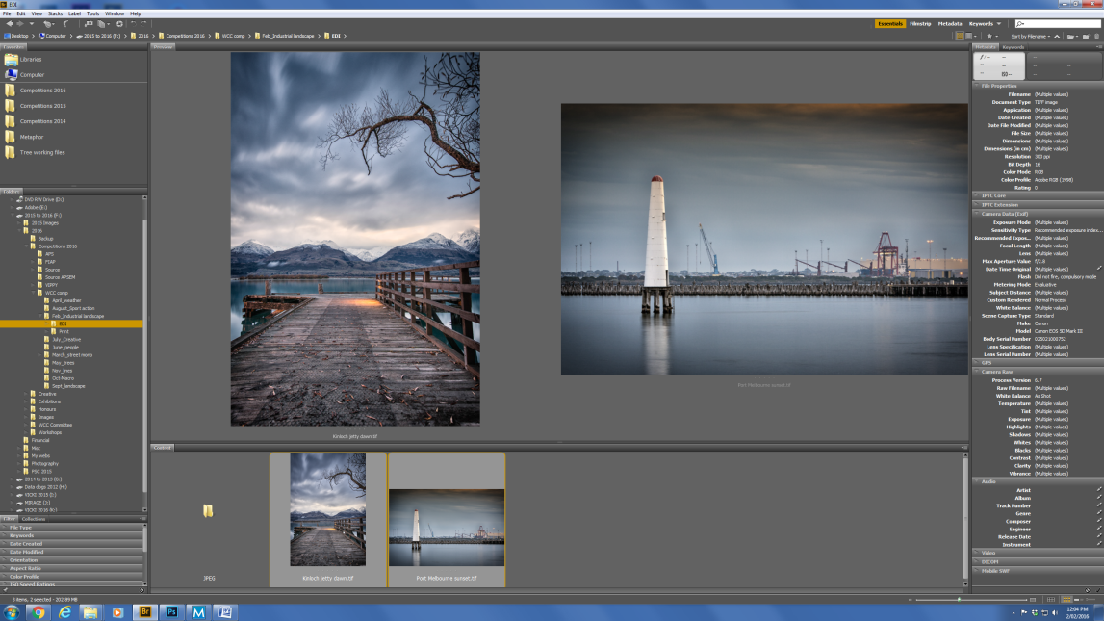

2. From the "Tools" menu choose Photoshop/Image Processor

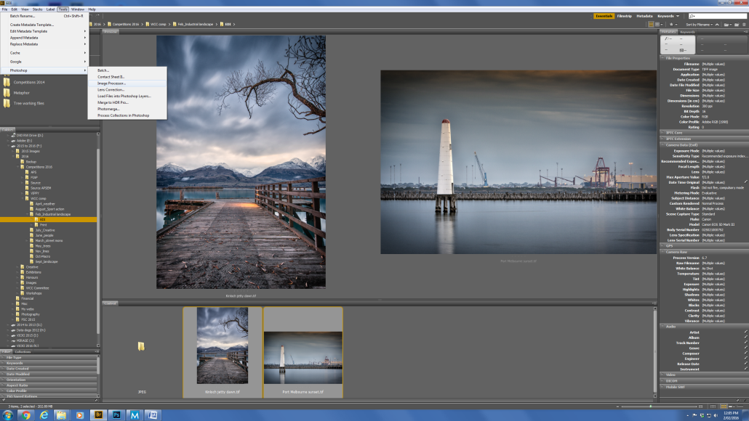
3. From the menu, if you choose "Save in same location" Bridge will make a folder called JPG and put your files in there. Otherwise, Select Folder to specify where you want them to go.
File type is JPG
Resize to fit is 1920x1080. This will automatically change your portrait orientation to the correct size with the vertical side being 1080 and the horizontal size being smaller
Quality at 10 should make sure most images are smaller than 2 Mb
Convert profile to sRGB
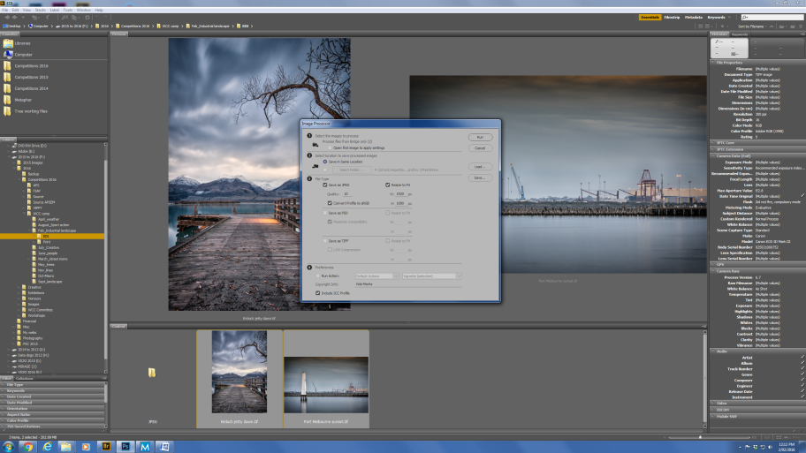

Using Photoshop (Photoshop CC 2015 and later)
1. New in Photoshop CC 2015, under the Export menu is the "Export As" option
Set Format as JPG, Image size with maximum height as 1080, Resample as Bicubic sharper if you are reducing the size and tick Convert to sRGB. I also usually include the copyright and contact information I have previously set in Photoshop and Lightroom. Reduce the Quality parameter if your file is greater than 2 Mb

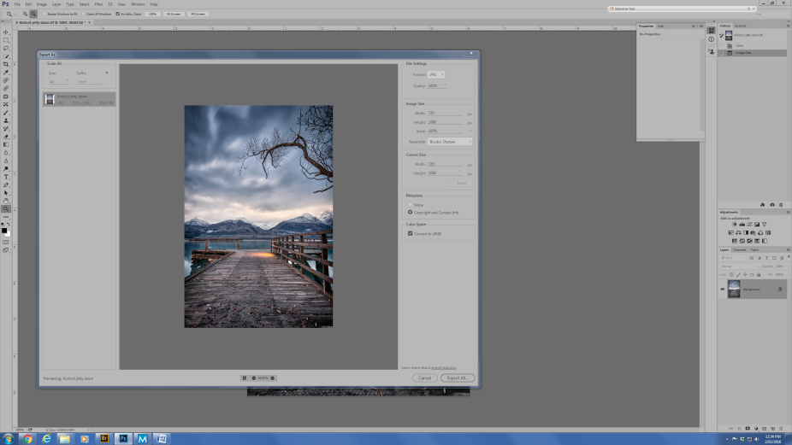

Using Photoshop (Method 2, for older Photoshop versions or to reduce to 72dpi)
1. From the top menu chose File, Export, Save for web (Legacy). N OTE: This is for Photoshop CC and is higher on menu hierarchy in earlier versions of Photoshop

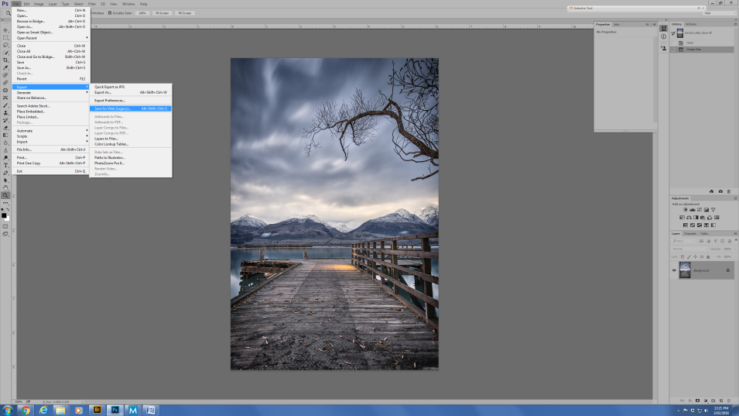

2. Set your JPG Quality to 100 if the file is less than 2 Mb in the top RH box. Tick Convert to sRGB, Set Image size (height no greater than 1080)

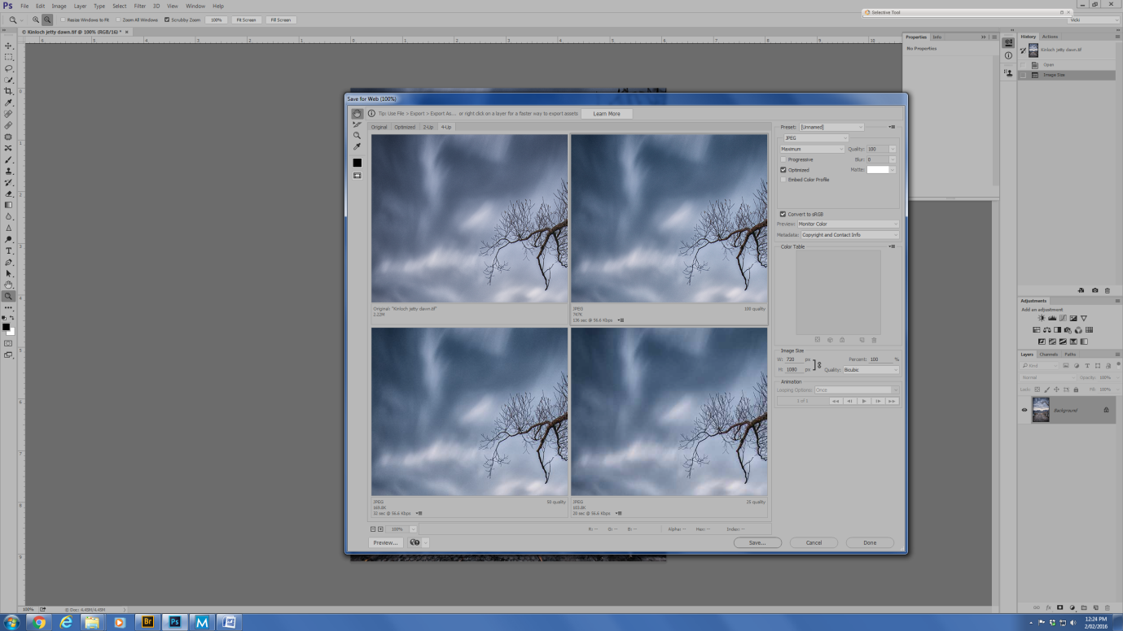
NOTE: If you resize using the top menu of "Image Size" from the Edit menu at the top, this does not allow you to change your colour space to sRGB from the Adobe RGB you are probably using as your default colour space. Best not to resize using this option unless you need to change to 72dpi.

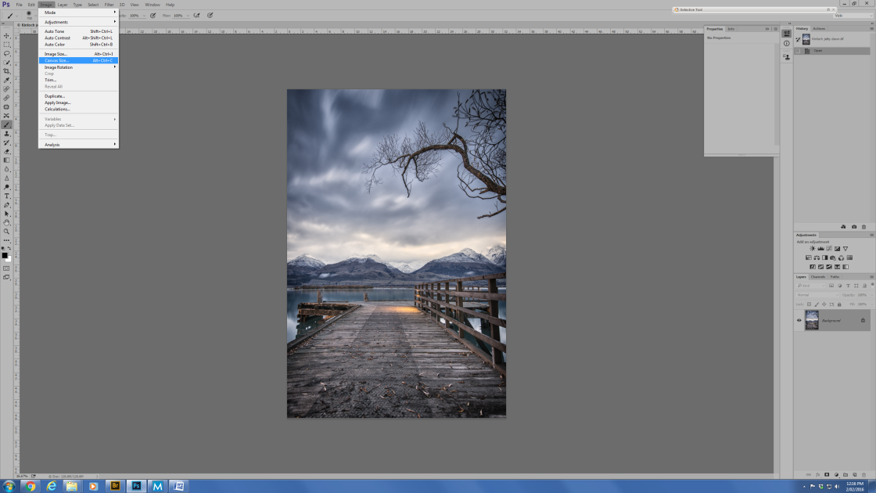

Vicki Moritz
2nd Feb 2016

